**Lab 8 Assignment**

**Working with DOCKER**

**Aim:** Re-Do the problem of Lab 5 using docker compose. Also do assign a static IP address to WordPress container using subnetting.

Create two docker containers with front-end and back-end applications and connect these containers using docker compose.

1. **Running WordPress container normally**

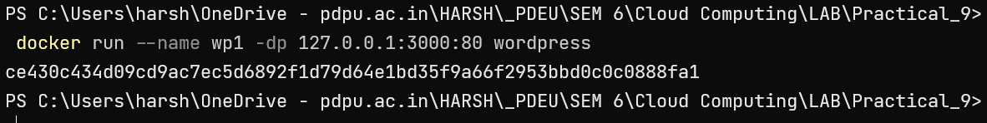

1. **Creating *compose.yaml* file**

services:

website1:

image: wordpress

ports:

- "3000:80"

1. **Execute Docker Compose**

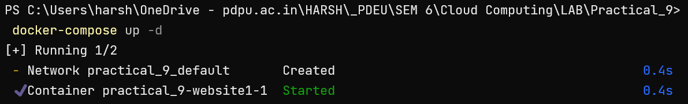

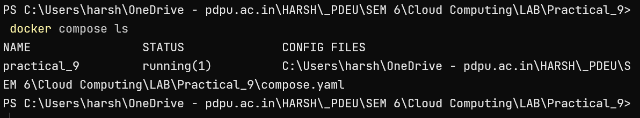

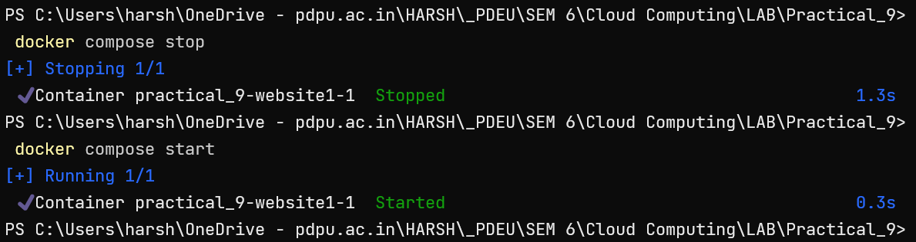

1. **Running multiple containers**

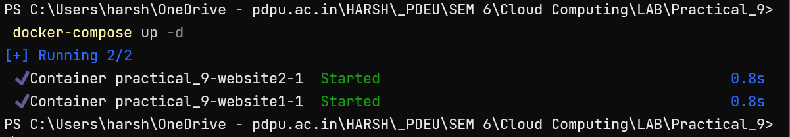

1. **Configuring network**

services:

  website1:

    image: wordpress

    ports:

      - "3100:80"

  website2:

    image: wordpress

    ports:

      - "3200:80"

networks:

      wordpress_net:

        ipv4_address: 192.168.99.20

networks:

  wordpress_net:

    ipam:

      driver: default

      config:

        - subnet: "192.168.99.0/24"

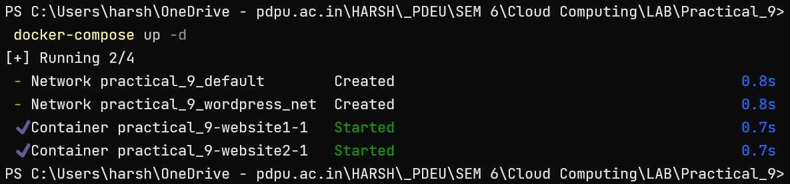

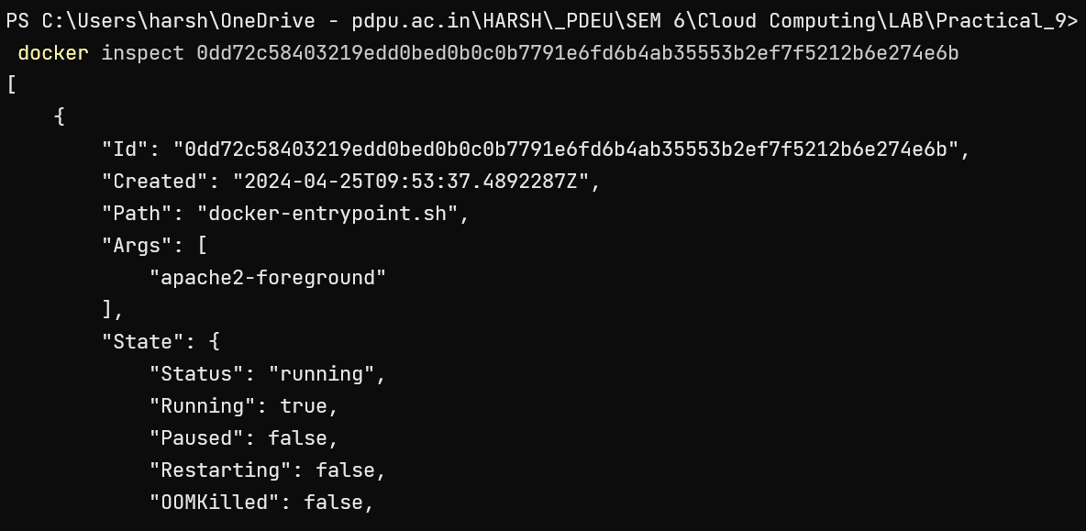

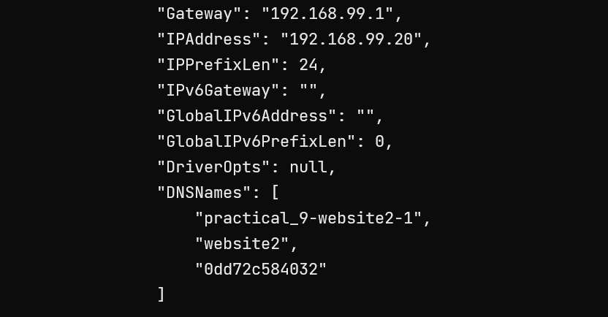

1. **Connection Database with Container**

version: "3"

services:

  mariadb_db:

    container_name: mariadb_container

    image: mariadb

    restart: always

    environment:

      MARIADB_ROOT_PASSWORD: password

      MARIADB_DATABASE: testdb

      MARIADB_USER: harsh

      MARIADB_PASSWORD: wp_password

    volumes:

    - mariadb_vol:/var/lib/mysql

  wordpress:

    depends_on:

      - mariadb_db

    image: wordpress:latest

    restart: always

    ports:

      - "8000:80"

    environment:

      WORDPRESS_DB_HOST: mariadb_db:3306

      WORDPRESS_DB_NAME: testdb

      WORDPRESS_DB_USER: harsh

      WORDPRESS_DB_PASSWORD: wp_password

    volumes:

      ["./:/var/www/html"]

volumes:

 mariadb_vol: {}

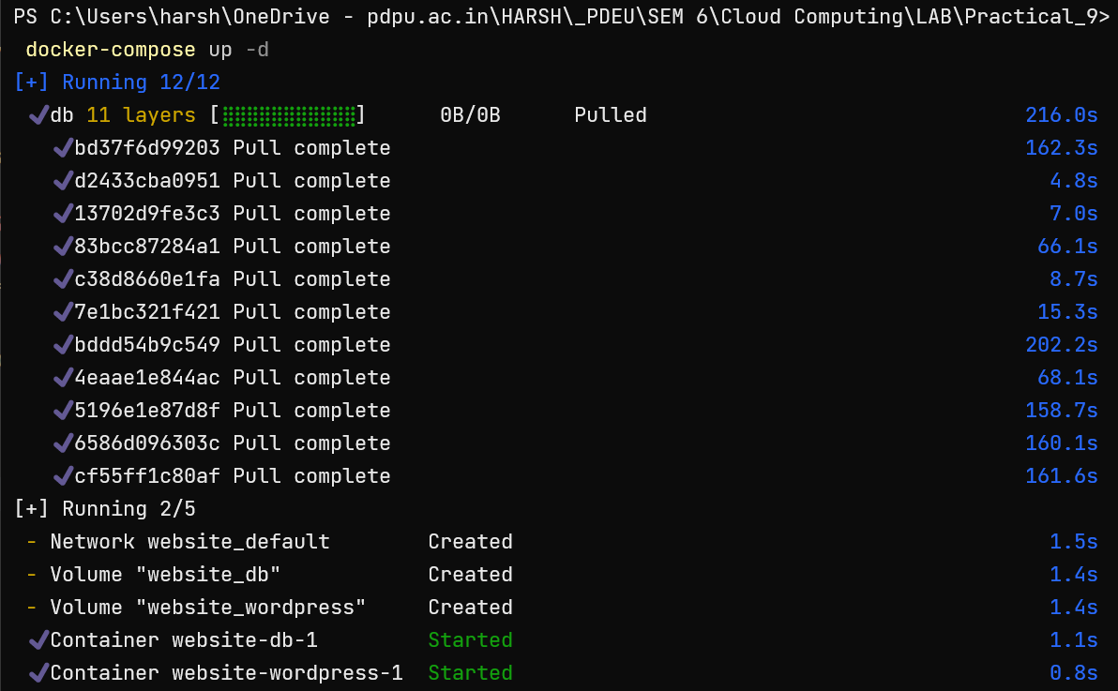

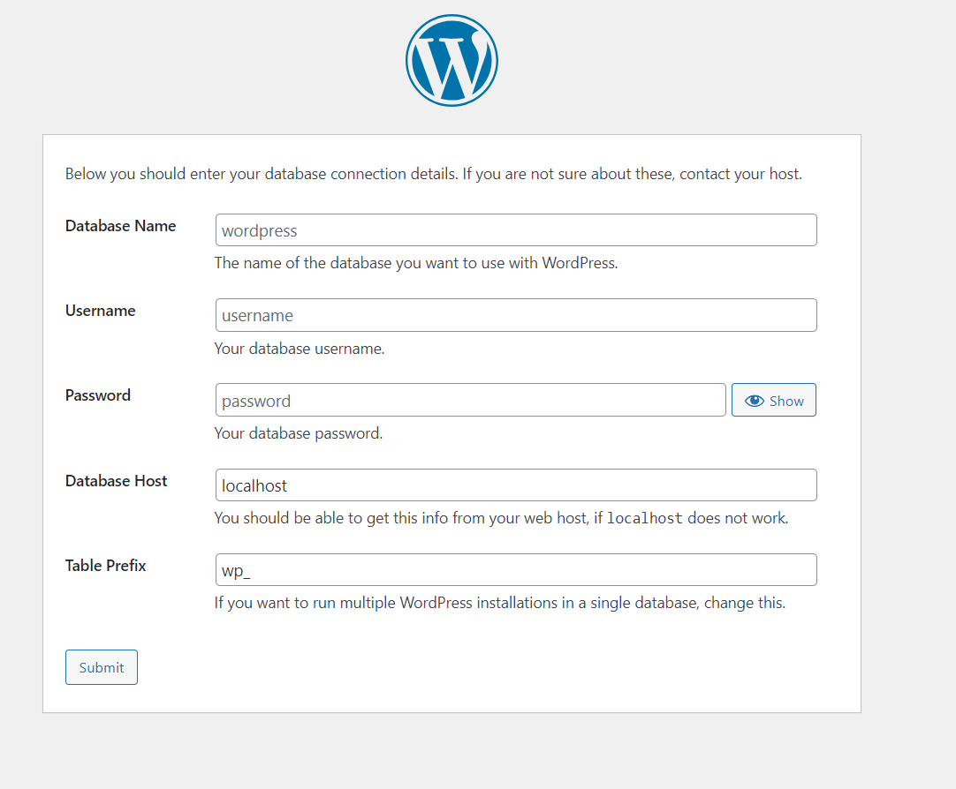

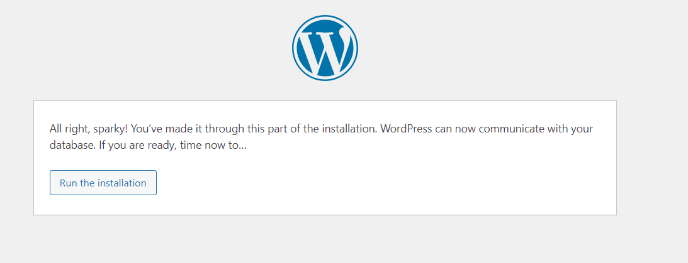

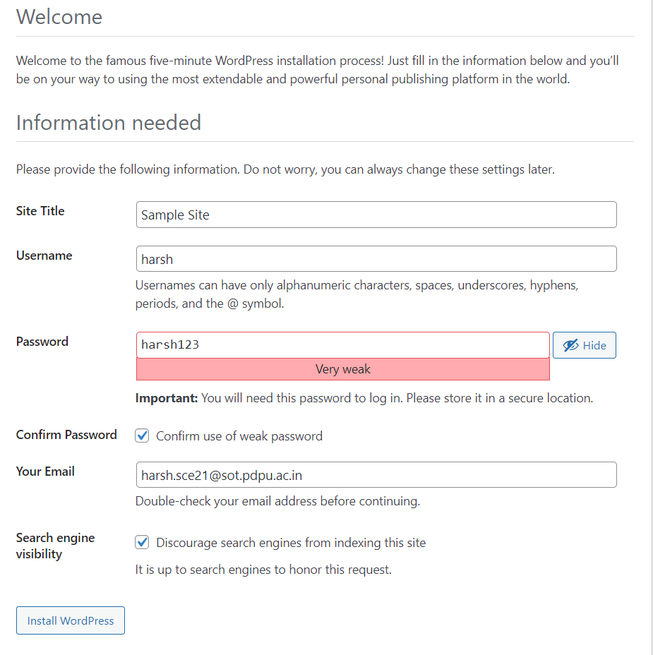

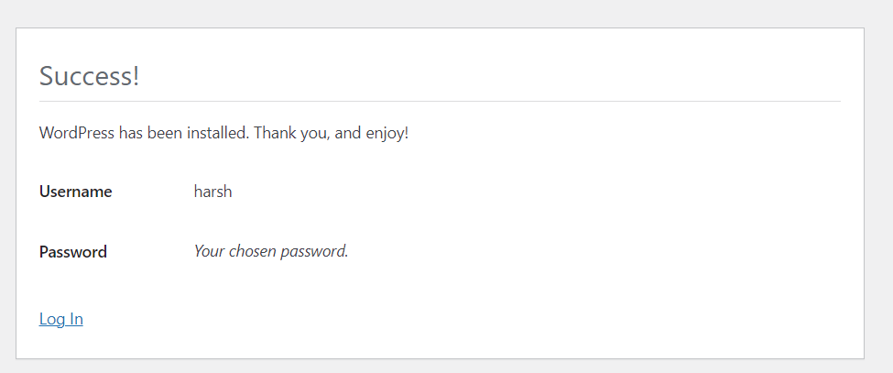

1. **Access Website on HostIP:PORT**

<http://127.0.0.1:3300/>